1) Display all the contact list

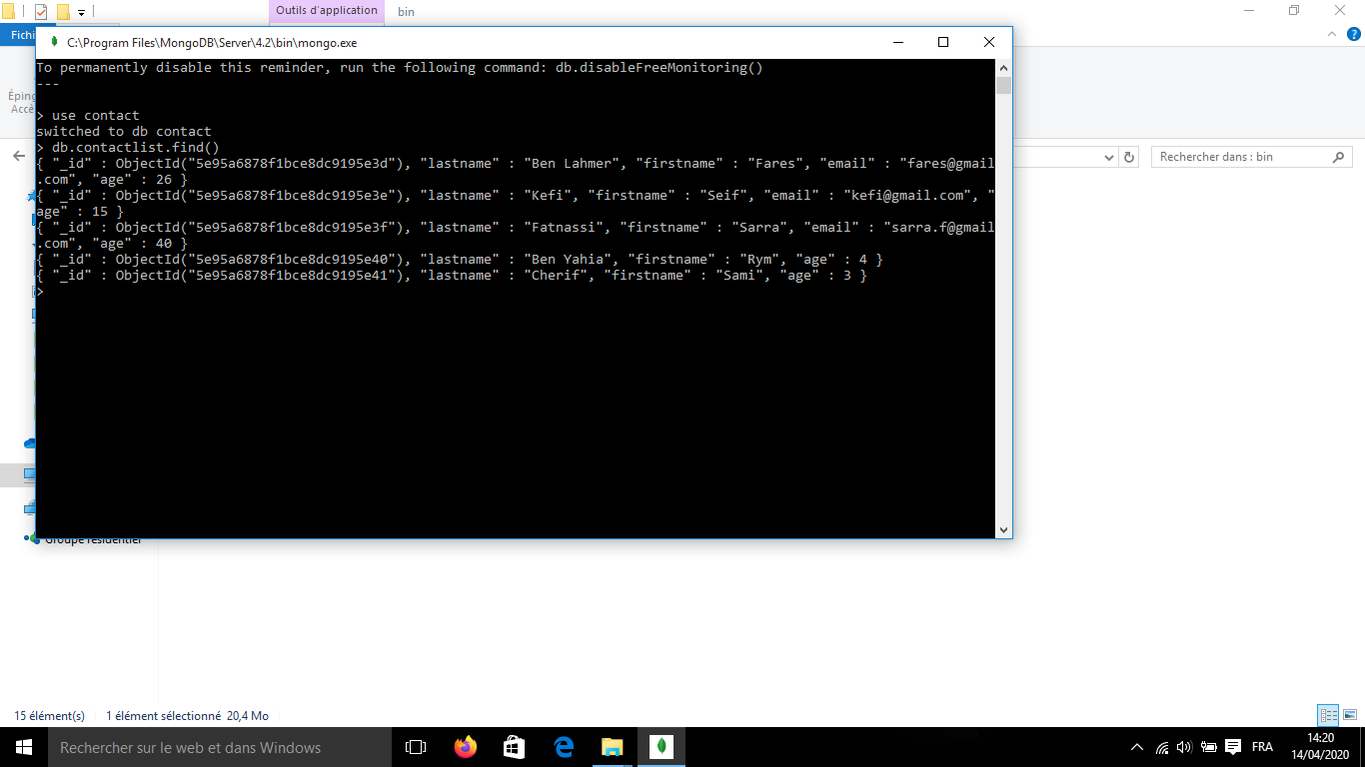

* 2 : Display all the information about only one person using his'  
  id :

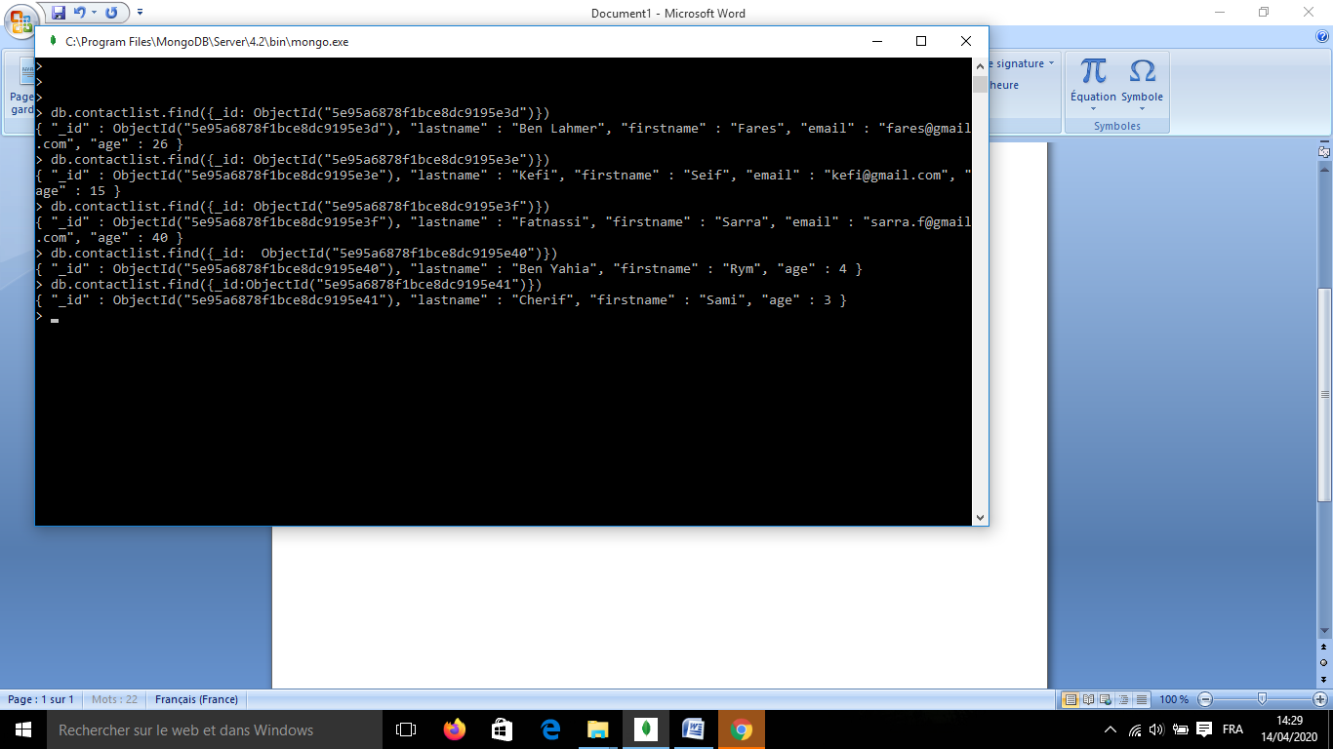

3 :Display all the contact list having age>18 :

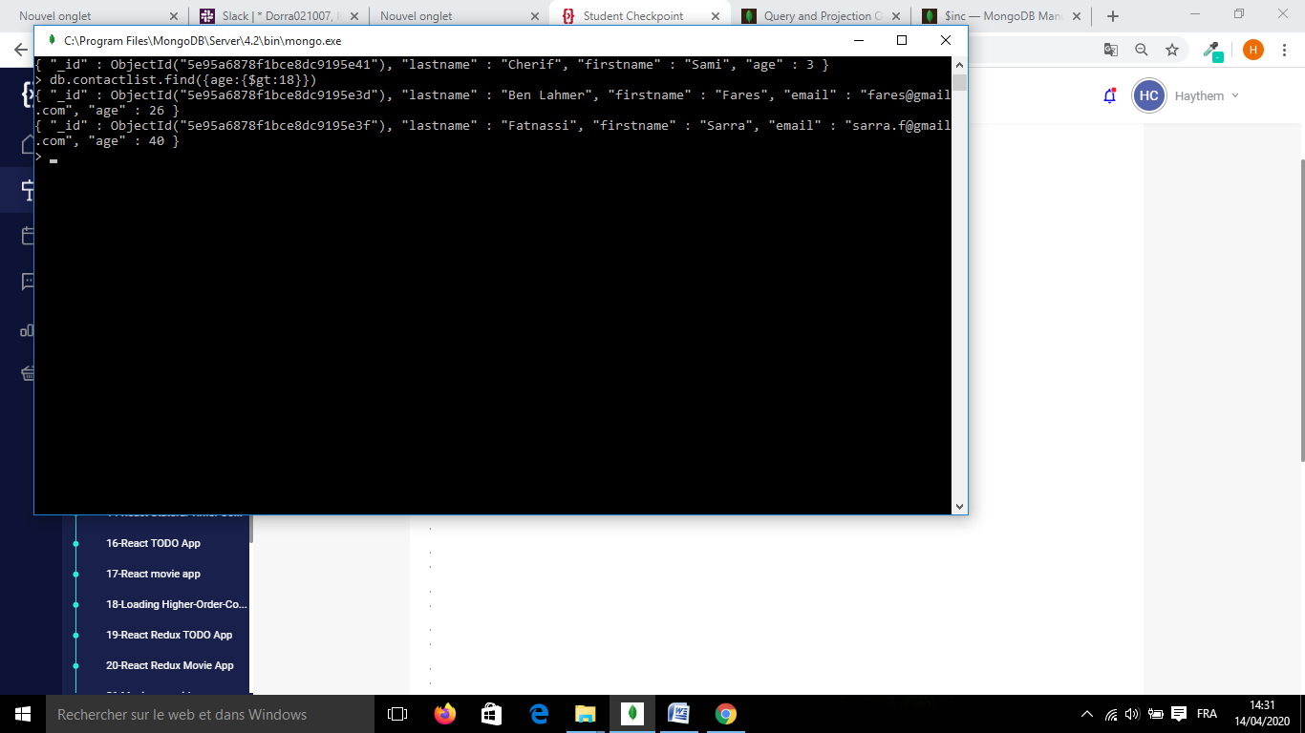

* 4 : Change the contact first name of "kefi Seif" by'  
  "Kefi Anis"

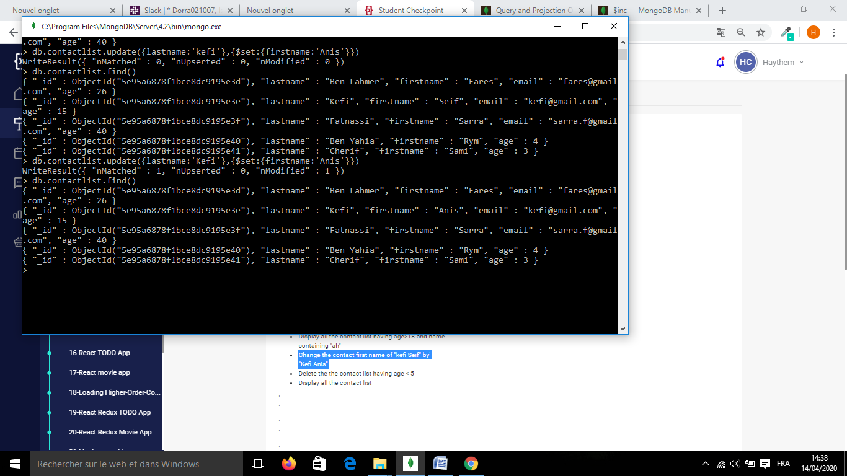

5)remove and display

